**Problem Statement**

Which semiconductor foundry exhibits the best balance of production efficiency, cost management, and order fulfillment capacity?

**Foundry Performance and Efficiency Analysis:**

In the semiconductor industry, where production speed, cost efficiency, and the capacity to fulfill orders are crucial, assessing the overall performance of a foundry is essential. This involves considering not only how quickly and cost-effectively a foundry can produce chips but also its ability to handle and complete customer orders. The following metrics are crucial for this analysis:

**Production Efficiency Rate:** This measures the average number of chips produced per day, indicating the foundry's production speed and capacity.

**Cost Efficiency Ratio:** This ratio reflects how cost-effectively the foundry operates, calculated by dividing the total production cost by the average production time in days. It provides insight into the foundry's cost management relative to its production timeline.

**Foundry Efficiency Ratio:** A crucial metric for this analysis, calculated by dividing the Production Efficiency Rate by the Cost Efficiency Ratio. A higher ratio suggests a better balance between production speed and cost-effectiveness, indicating a more efficient overall operation.

**Total Orders:** Reflects the foundry's market demand and capacity to handle customer orders, with a higher number of orders possibly indicating better market trust and operational capability.

This analysis aims to identify which foundry not only operates efficiently in terms of production and cost but also effectively manages customer demands. It is invaluable for stakeholders to understand which foundry offers the best balance of these aspects, guiding strategic decisions, investments, and operational improvements in the highly competitive semiconductor industry.

**SQL Code**

SELECT F.Name as Foundry_Name,

COUNT(DISTINCT PO.Order_ID) as Total_Orders,

COUNT(DISTINCT C.Chip_ID) as Total_Chips,

ROUND(AVG(DATEDIFF(PK.Date, PO.Date))) as Average_Production_Time_Days,

SUM(CPC.Production_Cost_Per_Chip) as Total_Production_Cost,

ROUND(SUM(CPC.Production_Cost_Per_Chip) / AVG(DATEDIFF(PK.Date, PO.Date)), 4)

as Cost_Efficiency_Ratio,

COUNT(DISTINCT C.Chip_ID) / AVG(DATEDIFF(PK.Date, PO.Date))

as Production_Efficiency_Rate,

(COUNT(DISTINCT C.Chip_ID) / AVG(DATEDIFF(PK.Date, PO.Date))) /

(SUM(CPC.Production_Cost_Per_Chip) / AVG(DATEDIFF(PK.Date, PO.Date)))

as Foundry_Efficiency_Ratio

FROM Foundry F

JOIN Testing T ON F.Foundry_ID = T.Foundry_ID

JOIN Testing_ON TON ON T.Testing_ID = TON.Testing_ID

JOIN Chip C ON TON.Chip_ID = C.Chip_ID

JOIN ( SELECT C.Chip_ID,

(CS.Cost + Tech.Cost + NC.Cost + CM.Cost + P.Cost) as Production_Cost_Per_Chip

FROM Chip C

JOIN Design D ON C.Design_ID = D.Design_ID

JOIN Clock_Speed CS ON D.CS_ID = CS.CS_ID

JOIN Technology Tech ON D.Tech_ID = Tech.Tech_ID

JOIN Num_Core NC ON D.Core_ID = NC.Core_ID

JOIN Cache_Memory CM ON D.Cache_ID = CM.Cache_ID

JOIN Power P ON D.Power_ID = P.Power_ID

) CPC ON C.Chip_ID = CPC.Chip_ID

JOIN Purchase_Order PO ON C.Order_ID = PO.Order_ID

JOIN WaferBatch WB ON C.Batch_ID = WB.Batch_ID

JOIN Packaging PK ON C.Chip_ID = PK.Chip_ID

GROUP BY F.Name

ORDER BY Foundry_Efficiency_Ratio DESC;

**Output**

**Bar Chart Representation**

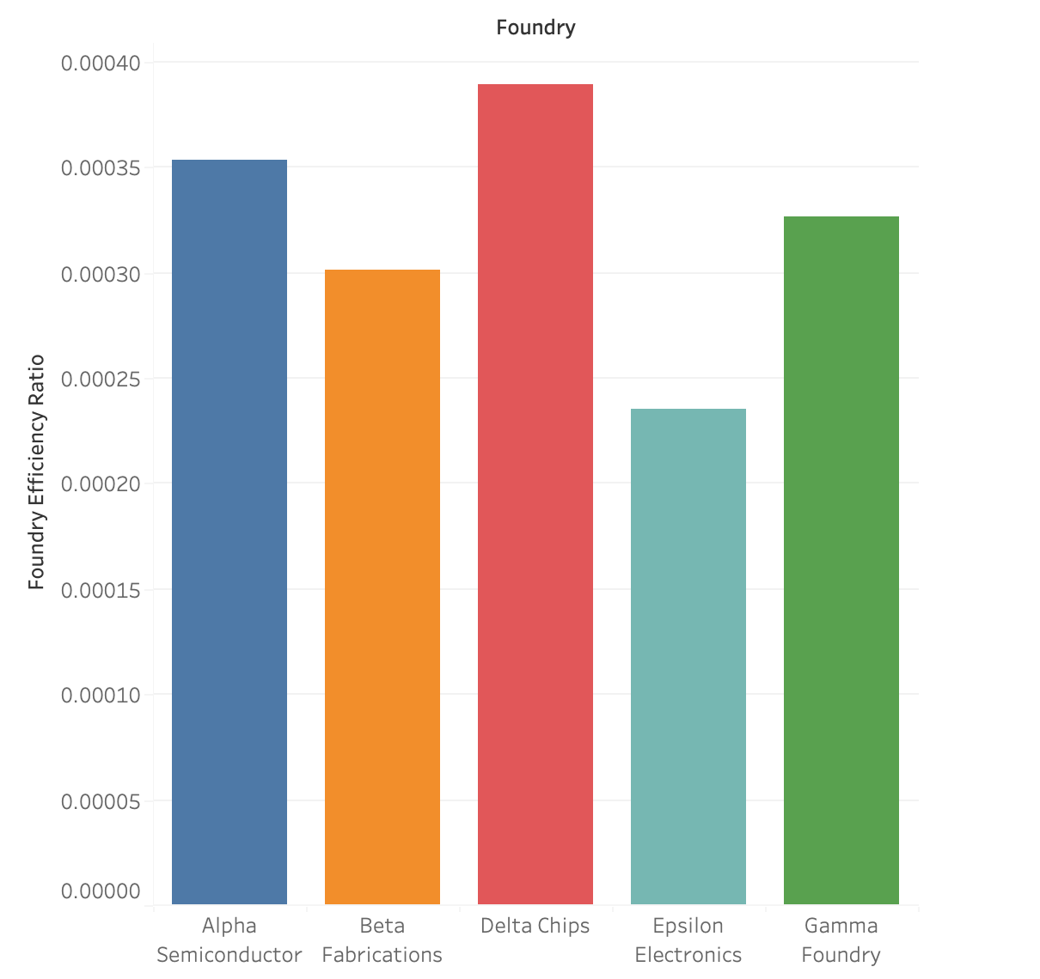

**Conclusion**

Based on the Foundry Efficiency Ratio, Delta Chips emerges as the best foundry among those listed. It balances production speed and cost management most effectively, resulting in the highest efficiency ratio.